1. **Karma(Ng Test successfully compiled)**

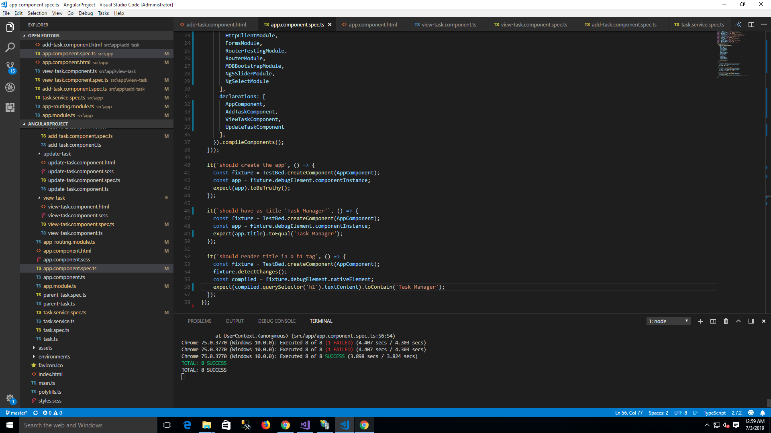

1. **Karma output:**

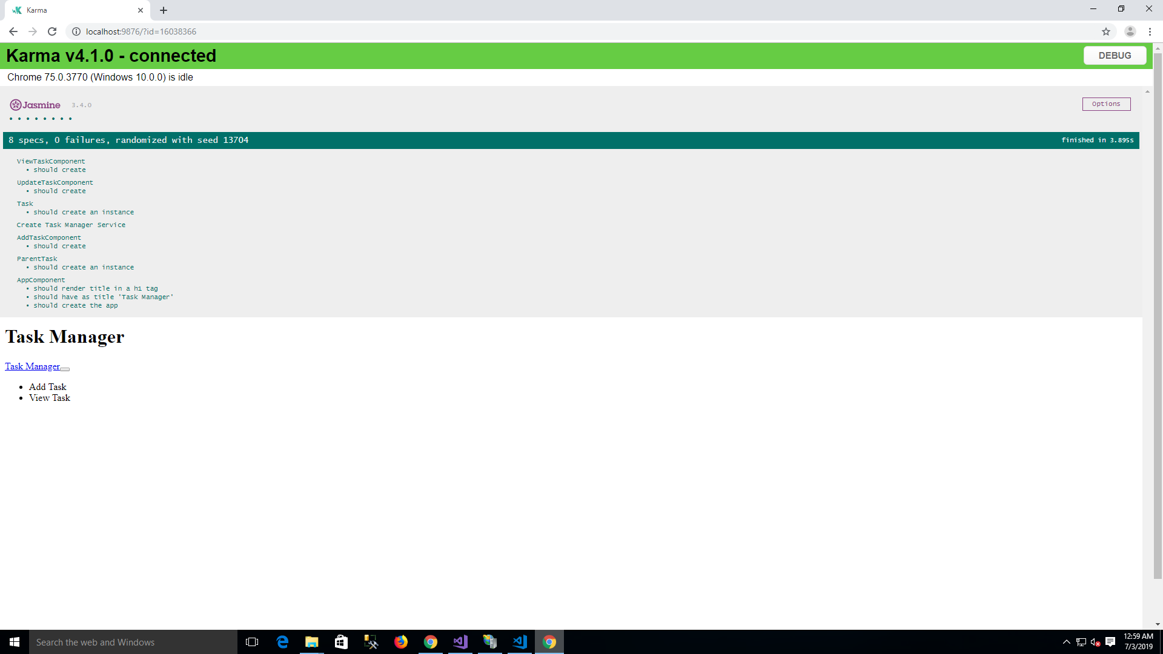

1. **Unit Testing Code coverage**

